

**Institute of Technology of Cambodia**

**Department of Information Communication Engineering**

**Subject: Internet Programming**

**Lecturer: HOK TIN**

**TP1: HTML and CSS**

Name: Doeurn Sreynith

ID: e20190214

Group: GIC-A

**2022-2023**

Contents

Ex1: 3

Ex2: 3

Ex3: 4

Ex4: 4

Ex5: 5

Ex6: 5

Ex7: 6

Ex8: 6

Ex9: 7

Ex10: 7

Ex11: 8

Ex12: 8

# Ex1:

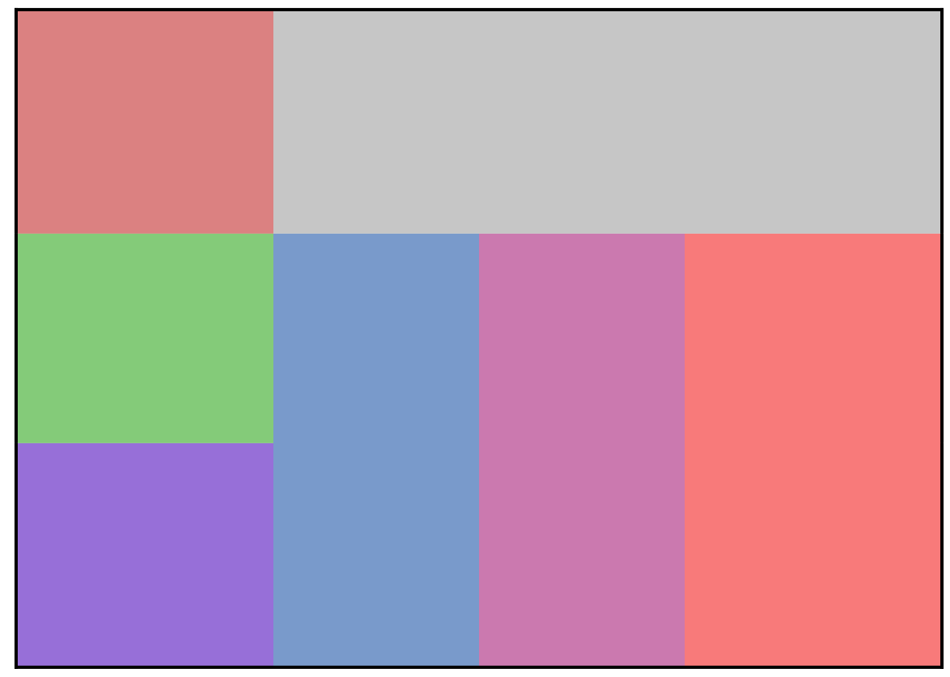

# Ex2:



# Ex3:



# Ex4:

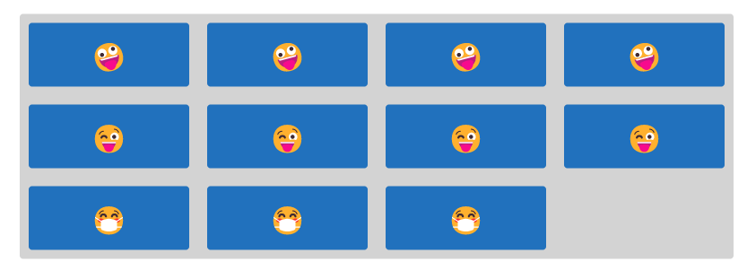

# Ex5:



# Ex6:





# Ex7:

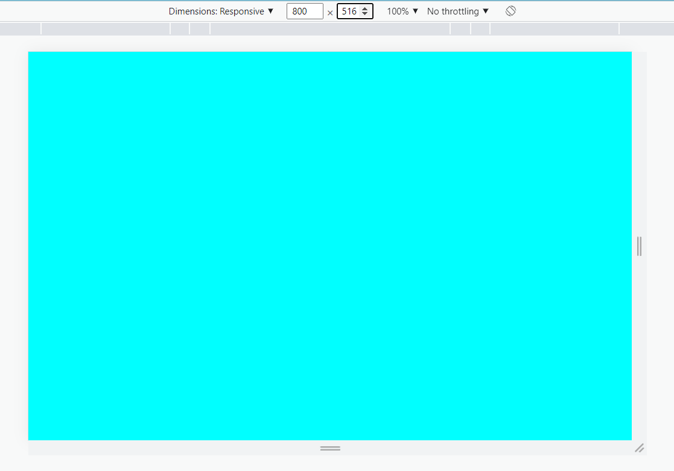

# Ex8:



# Ex9:

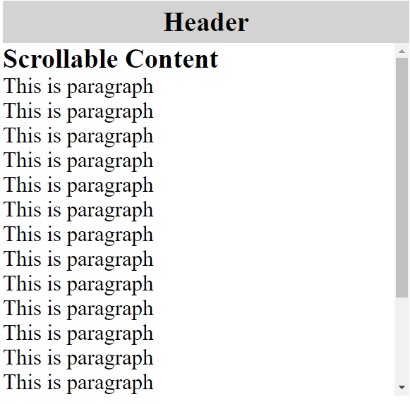

# Ex10:

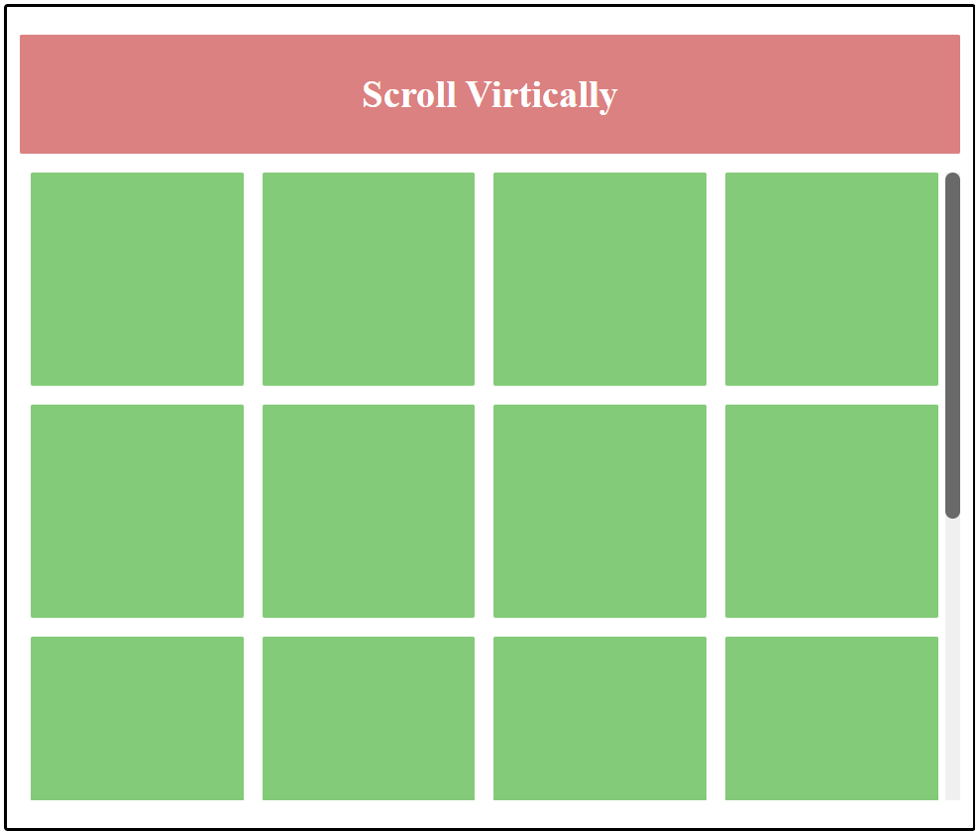

# Ex11:

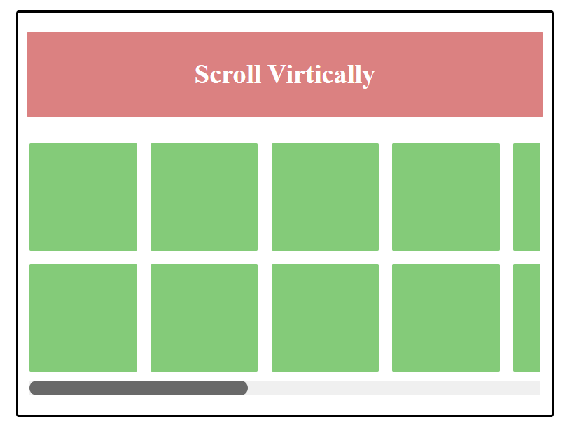

# Ex12:

